Created Aug 26, 2025 by Shelly Bagchi

VNC is used to remotely view the Teach Pendant screen and/or remotely control the robot.

To-Do:
- Set up VNC to run on start
  - May be a safety risk due to two-way control
  - We can require a password if needed
- Set up on one of the desktops
- Record screen from OBS
- In the Programming section, the dropdown menus and the numpads don't stay open (both on TP and on VNC), so it's basically impossible to set actual parameters (will look into this more). But, the waypoint programming works fine.
- Check out xvnc or x0vncserver (TigerVNC) - may be more lightweight

To run:
- Connect PC to same network as robot (if first-time, make sure to set an IP with the same subnet, 255.255.255.0)
- Connect to robot shell via ssh or USB keyboard (ctrl+alt+f1 to connect, f7 to return)
  - In Terminal, ssh root@169.254.152.41
  - pw: R0b0tz4nist!
- Run vnc:
  - x11vnc -display :0 …
  - -shared: allows multiple clients
  - -forever: keeps server up after client disconnects
  - -bg: runs in background after initialization
  - -passwd PASSWORD: plaintext, see below for more secure options
  - note: display ‘:0’ is default but the launch will be faster if you include the option
  - Option reference
- Open vnc viewer (e.g. TigerVNC, realVNC) & connect, e.g. enter 169.254.152.41:5900 (this port number should be default, would have been mentioned in the vnc startup). You should see the Teach Pendant screen, and you should be able to click buttons on the screen to use it as normal:
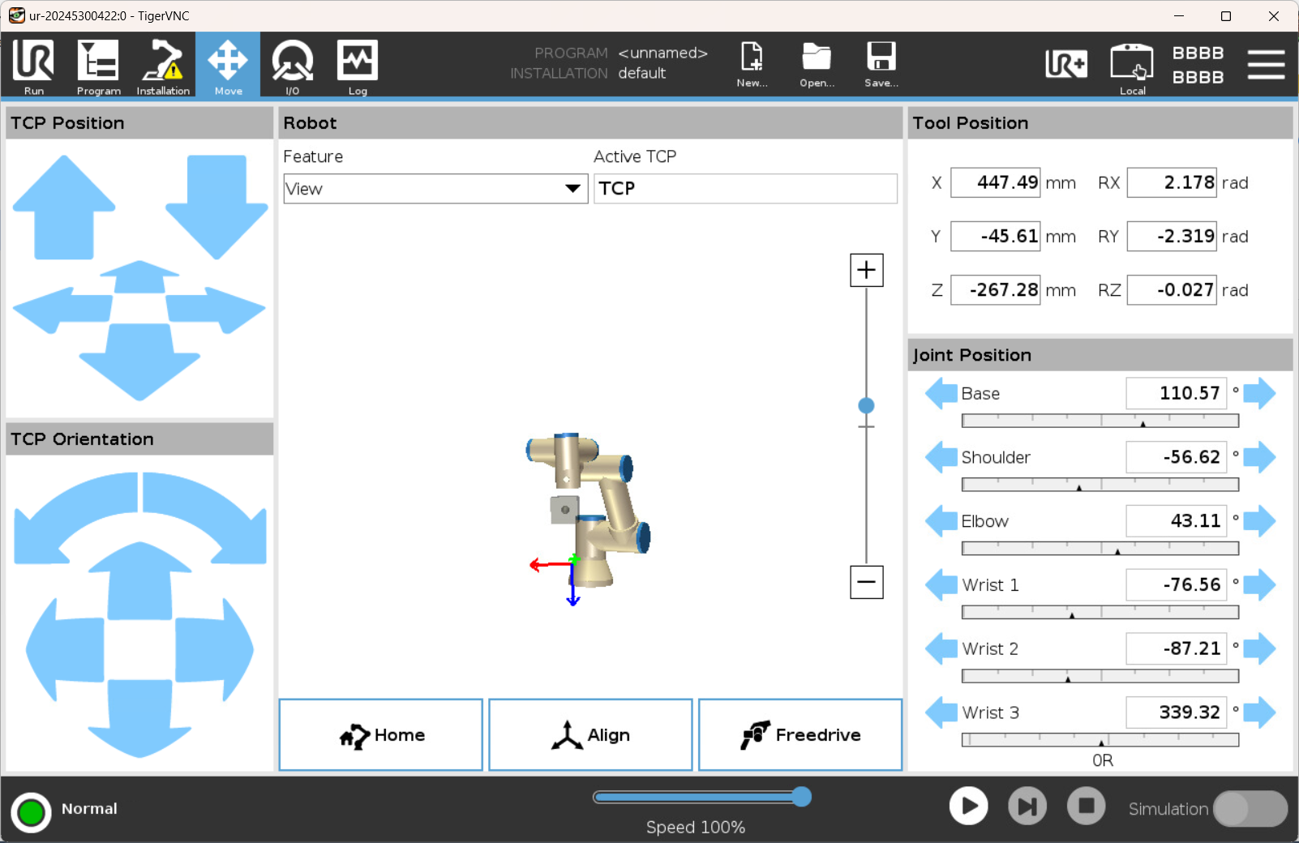
- To disconnect, close your vnc viewer and the server should automatically quit unless you used -forever.

To install:
- Asked ELDST to give temporary NISTnet access to the robot (need tag# and MAC address)

apt update
apt install x11vnc


References
From https://forum.universal-robots.com/t/remote-desktop-to-the-controller-ui/3826/8:
ssh into the robot
make sure the line in /etc/apt/sources.list starting with deb-src is not commented
Install screen and x11vnc:
apt-get update
apt-get install screen
apt-get install x11vnc
Add the following line to /etc/rc.local (obviously, somewhere above exit 0) so that vnc server is started automatically:
screen -dmS vnc x11vnc -forever [-clip 800x600+114+85 -scale 734x576]

Reboot robot and test with a vnc client

Another reference: https://forum.universal-robots.com/t/remote-desktop-to-the-controller-ui/3826/58
For what it’s worth, tested and working on 5.13 to install VNC by command line. use at your own risks:
Setup IP address on robot and your machine to SSH into the robot, root / easybot should be the defaults, robot should have internet access (plugged in a router for example)
edit /etc/apt/sources.list it should have all these uncommented:
deb http://archive.debian.org/debian jessie main
deb http://debian-mirror.ur-update.dk/debian jessie main
deb-src http://debian-mirror.ur-update.dk/debian jessie main
deb http://security.debian.org/ jessie/updates main
deb-src http://security.debian.org/ jessie/updates main

sudo apt update
sudo apt install x11vnc
x11vnc --storepasswd
Then set a password and save it in the default path.
to run from command line (for one-off interventions):
x11vnc -forever -noxdamage -display :0 -shared -rfbauth /root/.vnc/passwd
EDIT: running on boot does not seem to work with a password due to permissions, I’m still fiddling with this part, but it works all right over SSH, will edit things below when it’s fixed.
To run on boot, crontab -e and add line:
@reboot x11vnc -forever -noxdamage -display :0 -shared -rfbauth /root/.vnc/passwd
Then use any vnc client, on mac do “Go->connect to server” in finder and vnc://{robot_ip}:5900



